**CHAPTER 5**

**OUTPUT SNAPSHOTS**

Home page

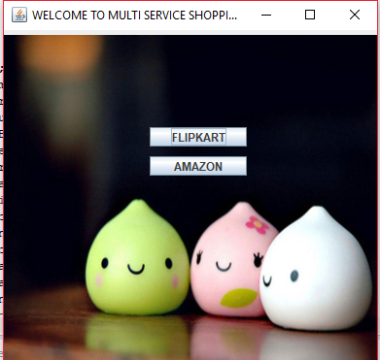

Login page

